Press contact:

Edwina A. Kluender
KLÜNDER Communications
617.888.5859 / eakluender@gmail.com

DATMA PRESENTS “SHELTER 2023”
Art non-profit to celebrate 5th anniversary with free public exhibitions and events

NEW BEDFORD, MA April 11, 2023 – Massachusetts Design Art and Technology Institute (DATMA), the non-collecting contemporary art institute, and its partners will once again bring a variety of free public art and programs to New Bedford, MA. To celebrate the 5th anniversary of DATMA’s founding, SHELTER 2023 will kick off June 22nd and present three outdoor artwork pieces, robust programmatic outreach and events, and educational workshops through October 23, 2023.

The history, economy, and culture of the SouthCoast region of Massachusetts is rooted in the value of shelter. This season, the artists invited by DATMA to present works focused on “shelter” are Mark Reigelman from New York City; Maxwell Emcays from Chicago; Silvia Lopez Chavez from Boston; and numerous SouthCoast artists. Topics covered include equality, a narrative of those who sought refuge, and a portrait of the people living and working in the diverse economy, depicting life at the intersection of land and water in New Bedford.

“Threshold” by Mark Reigelman
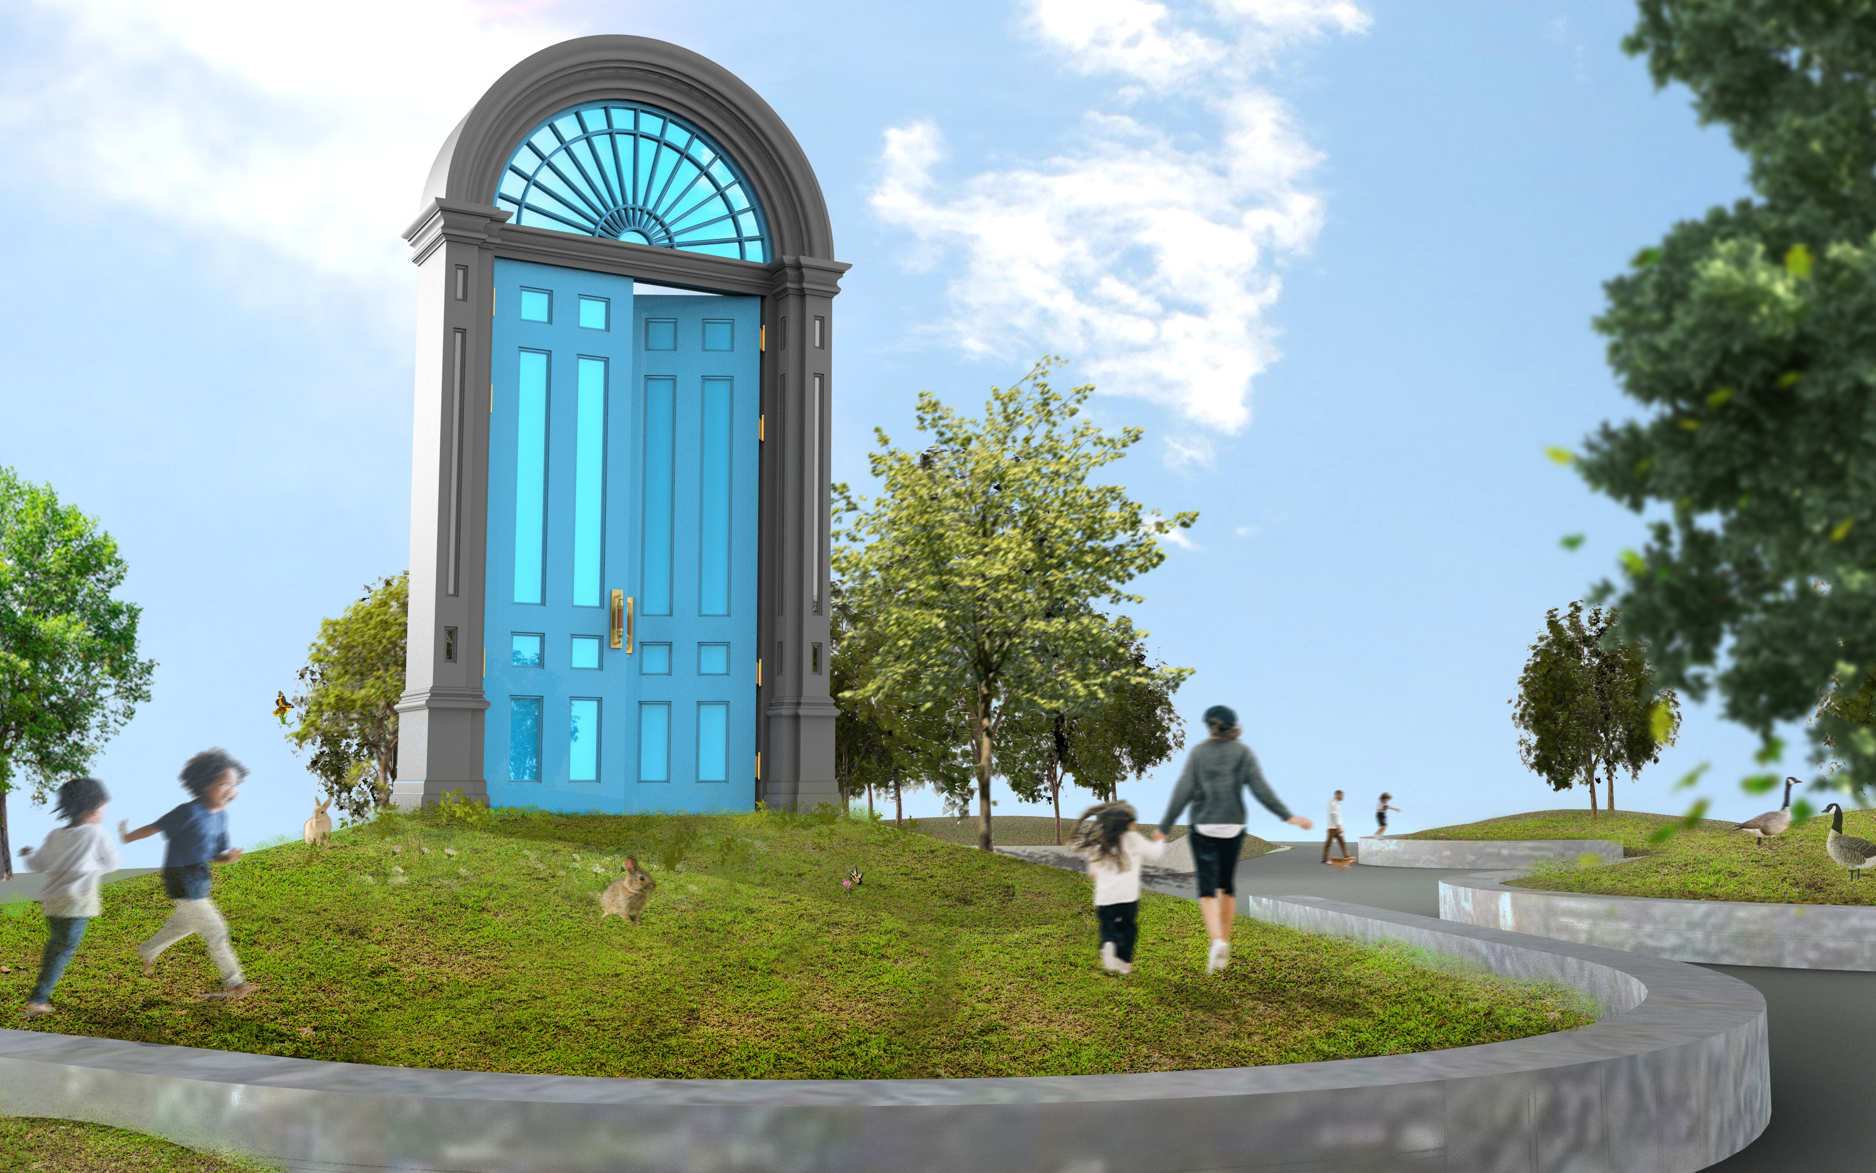
Rendering of Threshold by Mark Reigelman

Threshold will be a public artwork celebrating the principles of equality and community-building that have been integral to the history of New Bedford. Inspired by the Religious Society of Friends (Quakers) who inhabited the city in the late 17th century as well as the aesthetic of New England’s archetypal colonial doorways, sculptor Mark Reigelman beckons viewers toward Threshold’s partially opened door, shining down on Custom House Square from its 17-foot-tall perch.

Constructed mainly from wood and steel, Threshold will draw on the unique architecture of the federal doorway of the site of the oldest building in New Bedford's Abolition Row Historic District, an important site in the early Black freedom struggle. Its double-sided door references the community’s diverse history, with its blue façade facing the Wharf and rising sun as a nod to the city's fishing roots, while its massive arched window is tiled together with colorful mirrored pieces, capturing the various identities and cultures that have made up the city. A suspended 8-pointed star references a hugely influential New England quilting pattern, activating the static sculpture with mirrored surfaces that encourage visitors to reflect and contemplate in and around the portal. With its massive ornate door, the artwork seeks to promote principles of openness and create a welcoming space, inviting everyone to pass through its threshold.

Threshold will be on view free and open to the public at Custom House Square in New Bedford and is intended to be explored, interacted with, and used as a backdrop for gathering and events.

“Our Woven Story” by Maxwell Emcays

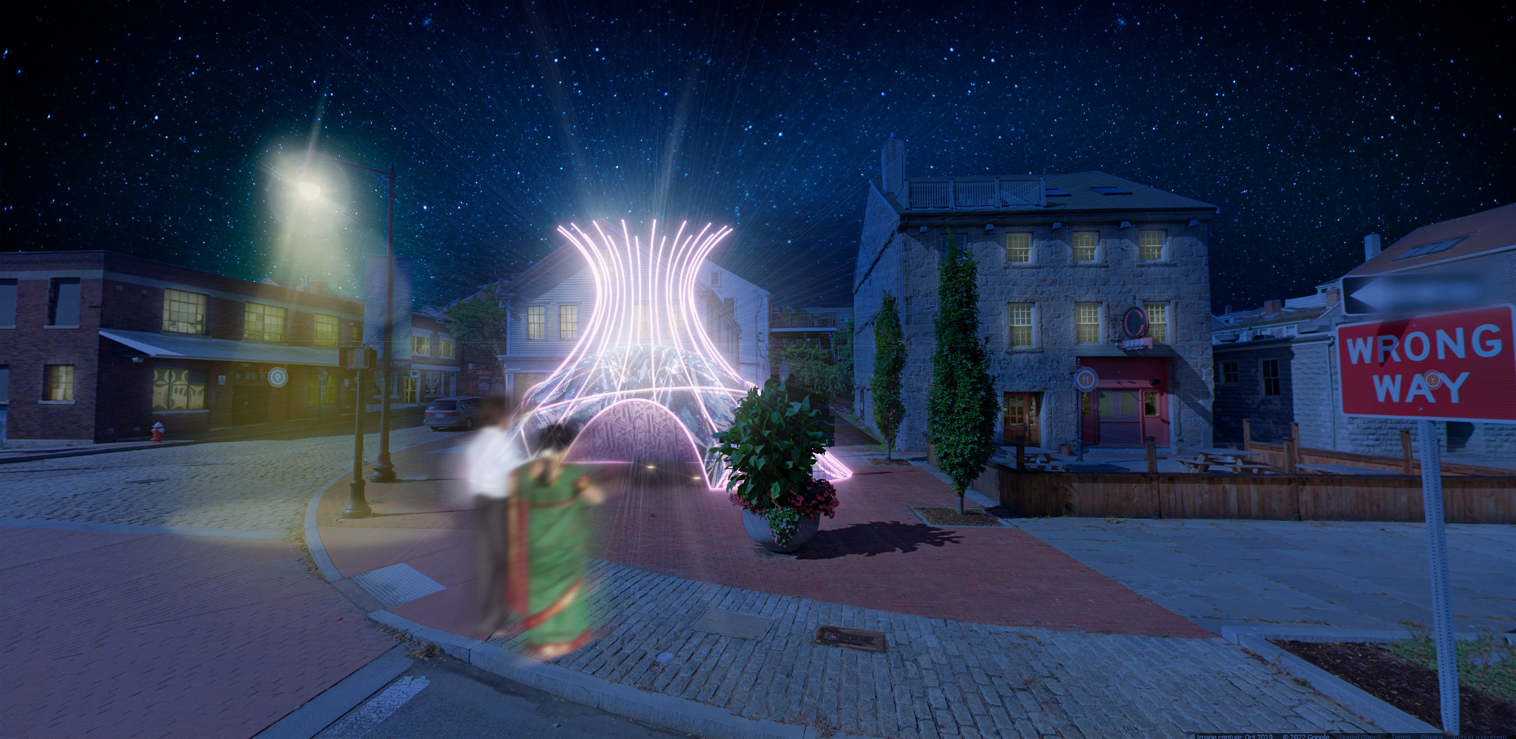

Rendering of Our Woven Story by Maxwell Emcays

As the winner of DATMA’s first national Request for Qualifications, mixed media multidisciplinary artist Maxwell Emcays will present Our Woven Story. The sculpture is inspired by the visual forms of the African Baobab tree and Wampanoag Wetu structures. Through the use of locally upcycled clothing as a primary material, textiles will embed the identity, economy, and social fabric of New Bedford’s community into the artwork. Emcays specifically focuses on the textile industry and the new immigrants which once made the city the wealthiest in the world. While today’s immigrants are not part of that, the stories remain similar with groups from nations like the Azores Islands, Cabo Verde, Salvador, Dominican Republic, Mexico, Honduras, Guatemala and others seeking shelter in new communities. The final lit piece will serve as a representation of the city’s community and culture, and intends to foster creativity, conversation, and connection among people.

“I consider myself a Chicago based Bantu American artist from The Maravi Empire,” shared Emcays. “My heritage spans the lands where the African baobab flourishes. Despite sprouting in lands and weather conditions where there is little nourishment, the Baobab have provided protection, supplement and refuge for a diverse ecosystem. With the moniker ‘The Tree of Life,’ I find it fitting that the U.S. was founded under similar principles of ‘shelter’ as the Baobab. A resource and ecosystem for people from all walks of life to find refuge under the branches of the American tree. Of course, this tree is held together in part by the fabric of those that work the hardest and are rewarded the least.”

Our Woven Story will be on display free and open to the public at the intersection of Route 18 and Union Street in New Bedford and is intended for visitors to walk around, through the three entrances and explore as well as using the space underneath for small gatherings or pop ups.

“Community Tides” by Silvia Lopez Chavez
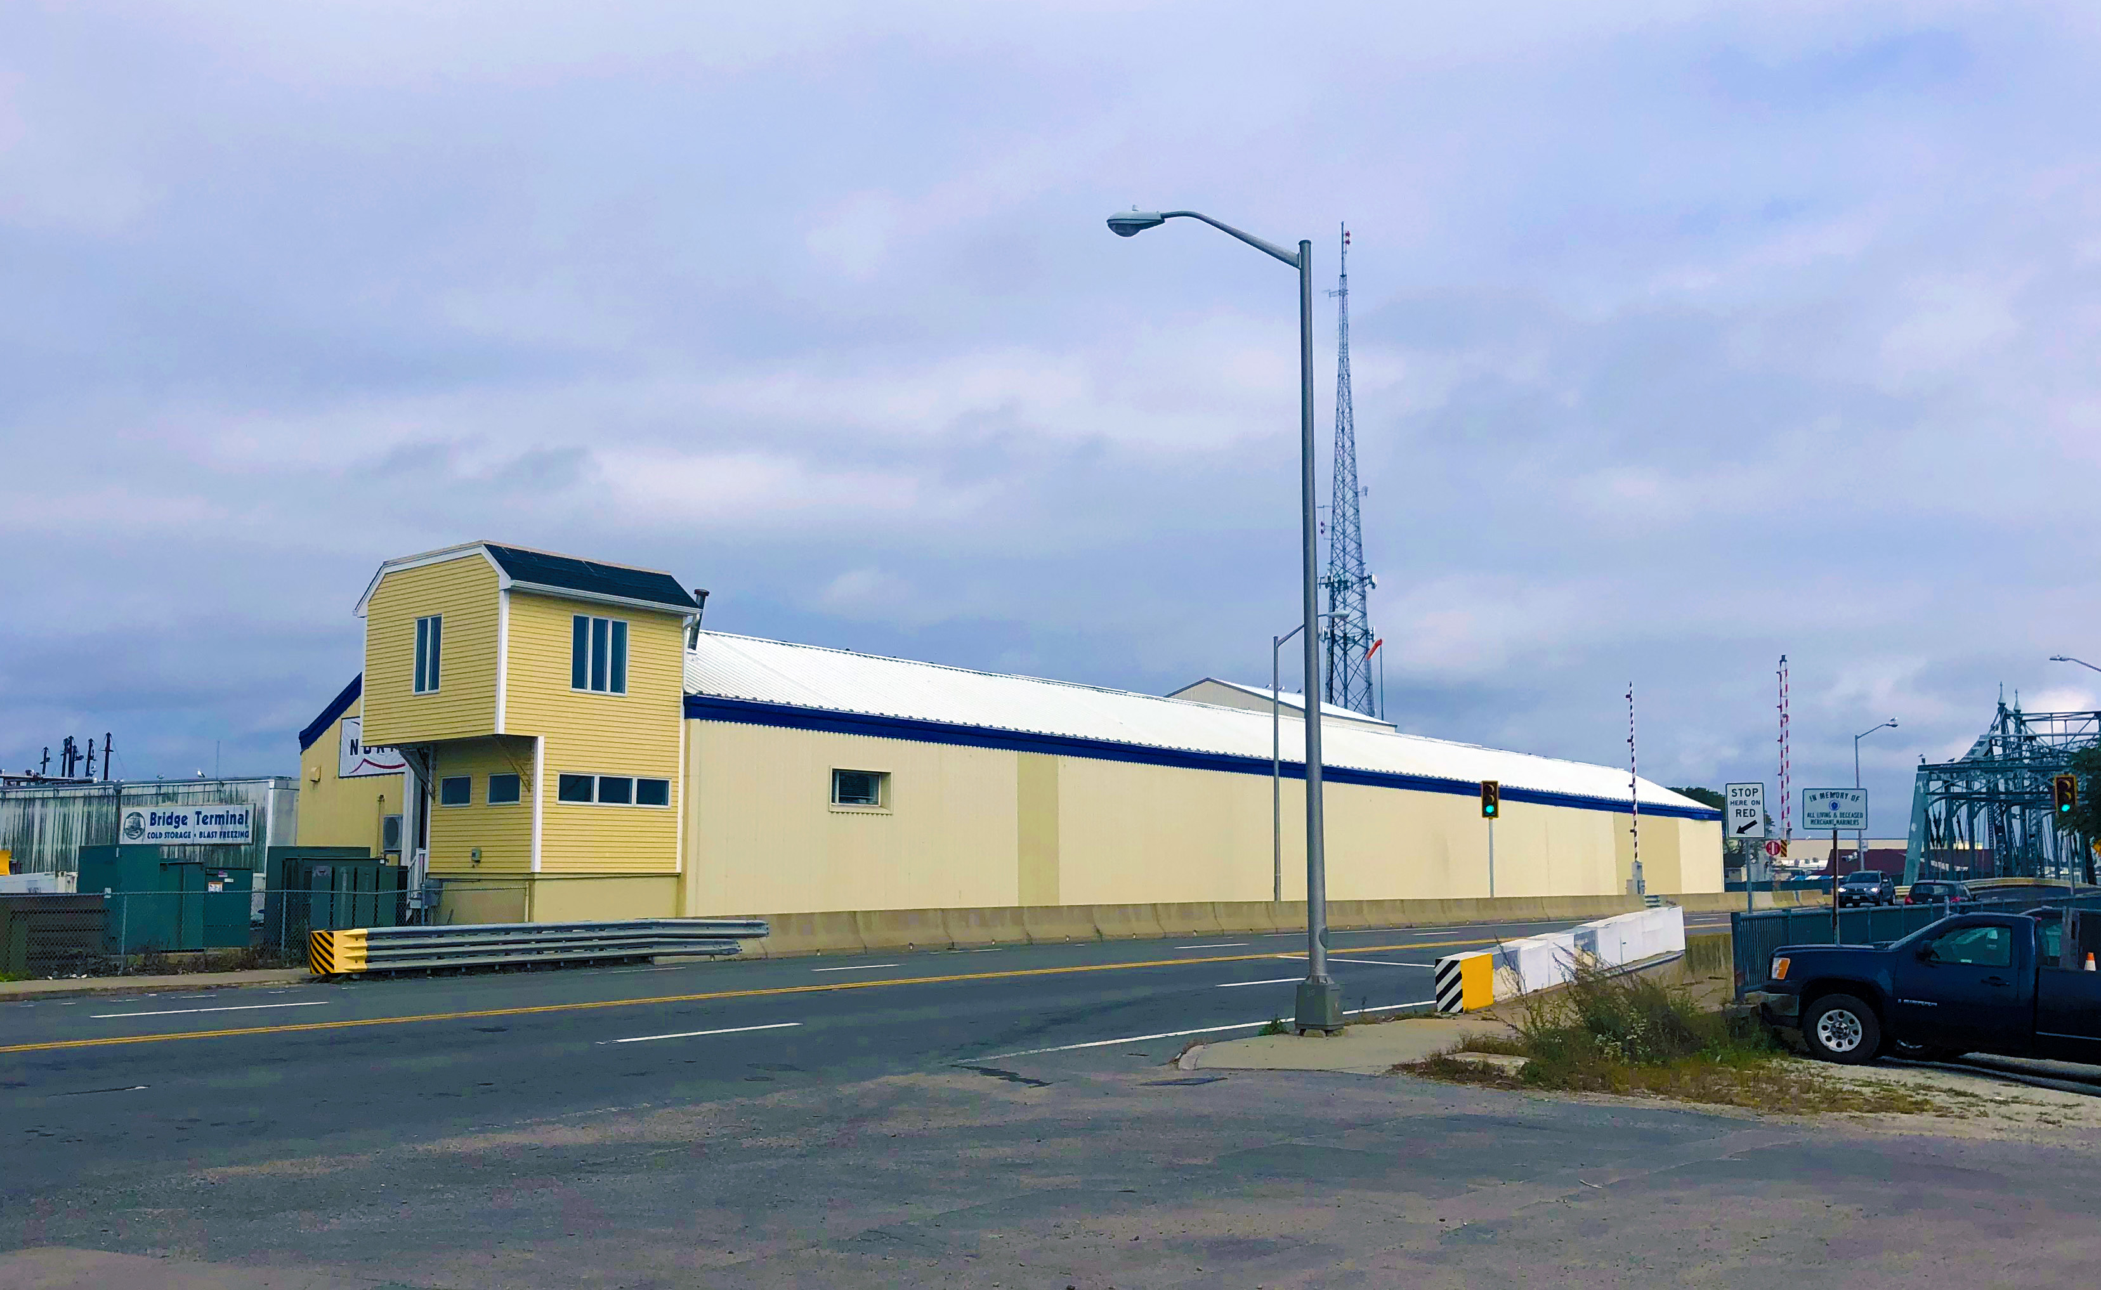
Image of NORPEL exterior wall, photo by Lindsay Mis
Community Tides will be a mural portraying the New Bedford’s community, the fishing industry, its diverse economy, and depiction of life at the intersection of land and water. Silvia Lopez Chavez will collaborate with New Bedford High School students to create her signature colorful patterns pulled from the student’s local landscapes and everyday lives. Utilizing acrylic paint, spray paint, and stencils to design various sizes of layered panels, New Bedford’s local youth will explore STEAM technology and design innovation to help contribute to the final design of Community Tides. In partnership with Northern Pelagic Group (NORPEL), the semi-permanent mural will measure 223 feet in length by 10 feet in height, the first piece of contemporary art on Fish Island.

Community Tides will be shown free and open to the public on the NORPEL exterior wall adjacent to a prominent New Bedford roadway along the New Bedford-Fairhaven Bridge, prominently viewable from the land, sea, and air.

Open Studios on the Sidewalk by various SouthCoast artists
To celebrate DATMA’s 5th anniversary, DATMA will highlight the important role of artists in shaping and creating the local community, the ultimate shelter for a city. New Bedford and its surrounding towns are home to countless creatives including New Bedford, Fall River, Brockton and more. DATMA will offer SouthCoast artists, who may have never considered their work to be “the right medium” for public art, the opportunity to be showcased through images that will be displayed in an outdoor print exhibition. Open Studios on the Sidewalk will “open doors” to the different creative practices in the region, outside the typical “white-cube” gallery, and will showcase the unique spaces where artists produce work regionally. A full list will be available on www.DATMA.org soon.
Open Studios on the Sidewalk will be on view at Tonnessen Park and entrance of Seastreak Ferry building in downtown New Bedford.

“We are particularly excited about this year – our 5th anniversary,” shared Lindsay Mis, Executive Director of DATMA. “We're focused and hitting our stride featuring a wide range of entirely outdoor public art exhibitions that continue our theme of Shelter. Our artists have invested a great deal of creative time to connect with our community by working closely with students, local artists, and organizations. I'm proud of how far we've come in our first 5 years and look forward to many more.”
Additional programming that are all free and open to the public from DATMA and partner collaborators during “SHELTER 2023” will include:
- April 13 Event from 5-7pm: New Bedford: Our Woven Story at 3rd MakerSpace at New Bedford Whaling National Historical Park, 33 William Street, New Bedford
Join DATMA, artist Maxwell Emcays and students from Our Sisters’ School for an evening for celebrating textiles, art, and fashion.

- May 11 Event from 5-7pm: Family Design Day: Community Mural at New Bedford Whaling National Historical Park, 33 William Street, New Bedford
Add a creative touch to the Community Mural during August AHA! Inspired by artist Silvia Lopez Chavez, this collaborative mural is about celebrating color and pattern in new ways. All art supplies will be provided at the event. This event is presented in collaboration with 3rd EyE and Superflat NB as part of AHA! New Bedford and SouthCoast Spring Arts Week.

- June 22 Event from 5-7pm: DATMA’s 5th Anniversary Public Opening Celebration at Custom House Square, 21 Barkers Lane, New Bedford
With fun and festivities for the whole family, DATMA invites everyone to join in celebration of 5 years of public art in New Bedford. Gather with public artists, community partners, and enjoy performances from local poets, dance groups, and more.

- July 13 Event from 5-7pm: Family Design Day: Public Art Pop-up at New Bedford Whaling National Historical Park Garden, 33 William Street; and Custom House Square, 21 Barkers Lane, New Bedford
Create a door and become part of a pop-up community art installation. Drawing on the unique architecture of New Bedford, Mark Reigelman’s “Threshold” installation represents history, community, and pride in our local landscape. Get inspired by exploring historic architecture and some of the city’s most special doorways with the New Bedford Preservation Society and New Bedford Whaling National Historical Park.

- August 8 - October 8 Exhibition: Under the Sheltering Sky at New Bedford Art Museum, 608 Pleasant Street, New Bedford
This exhibition will feature prints from the New Bedford Free Public Library’s first edition set of John J. Audubon’s Birds of America, and work by Brooklyn based artist Adrian Brandon. The Audubon prints will all contain birds in their nests, most of which have never been exhibited. From the purple martin’s hollowed out gourd to the highly specialized mud-nests of a colony of cliff swallows, each print will show a unique shelter used by the birds to lay their eggs and raise their fledglings. Audubon’s prints are known for both their accuracy and beauty, gained from his years of observing the birds in their natural habitats, living, hunting, and nesting.

- August 9 and 10 Workshop: Breaking Rules to Help Humanity - Exploring the Possibilities of 3D Printing at UMass Dartmouth ceramic facilities, New Bedford
DATMA has invited cutting-edge San Francisco based architect and designer, Virginia San Fratello, to New Bedford to teach local designers, artists, and educators how to push the boundaries of 3D printing using readily available earthen material. Participants will learn sustainable building and creative practices, and will be selected at random from the datma.org online sign-up form.
- August 20 Tour from 12-3pm: Open House at the Mansions at James Arnold Mansion, 427 County Street; and Rotch-Jones-Duff House and Garden Museum, 396 County Street, New Bedford
The two mansions connected by County Street and marriage (James Arnold married Sarah Rotch, daughter of William Rotch Jr.) will be co-hosting a free day of activities to include tours of the house, lemonade, and lawn games at Rotch-Jones-Duff House, whereas the Arnold Mansion will offer house and grounds tours, education about its historic trees, and fruit punch and cookies.
- September 12 Conversation from 6-8pm Climate Change in New Bedford - Exploring Probable Futures at Last Round Bar & Grille, 908 Purchase Street, New Bedford
In partnership with the New Bedford Science Café, the event will center around exploring the impacts and the future of climate change in New Bedford. Guest Speaker, Alison Smart, is the Executive Director of Probable Futures, a non-profit climate literacy initiative geared toward helping communities worldwide understand and adjust to climate change.

- September 14 Concert from 5-7pm by New Bedford Symphony Orchestra at Custom House Square, 21 Barkers Lane, New Bedford
Music is both a doorway and a shelter. Musicians of the New Bedford Symphony Orchestra will perform a concert at the Threshold installation with a program of music that embodies the spirit of both these enduring values.

Full details and additional programs are available on www.DATMA.org.

Partners for “SHELTER 2023”:
DATMA will collaborate with the commissioned artists, the City of New Bedford, and local nonprofits, schools, universities, and businesses to coordinate tours, student field trips, lead design, art, and technology workshops, host talks, and present digital exhibitions and documentaries. Partners include: Arts, History, Architecture (AHA!); Superflat NB, 3rd Eye Unlimited; Northern Pelagic Group, LLC (NORPEL); New Bedford Whaling National Historical Park; Our Sisters’ School; New Bedford High School; Greater New Bedford Regional Vocational Technical School (GNBVT); Renaissance Community Innovation School; New Bedford Preservation Society; New Bedford Science Café; New Bedford Park Department; New Bedford Food Tours; The New Bedford Free Public Library; New Bedford Art Museum/ ArtWorks!; New Bedford Symphony Orchestra; James Arnold Mansion; Rotch-Jones-Duff House and Garden Museum; and UMass Dartmouth’s College for Visual and Performing Arts (CVPA).
###

About the Massachusetts Design Art and Technology Institute (DATMA)
The Massachusetts Design Art and Technology Institute (DATMA) was founded to enhance the evolving dynamic cultural and economic life of Southcoast Massachusetts. DATMA is committed to bringing world-renowned art, design, and technology exhibitions, programs, and initiatives to the visitors and citizens of New Bedford and the region, identified as one of the Commonwealth’s most creative economies by the Massachusetts Cultural Council. As an exhibitor of public art, DATMA collaborates with the business and education sectors of the region to expand public awareness, bringing new cultural assets into the mix.

Last year, DATMA presented “SHELTER 2022-23” to examine the history, economy, and culture of the region which is rooted in the value of ‘shelter’ and covered a range of topics including today’s housing crisis, the Underground Railroad and the 9,100-foot-long hurricane barrier that protects the city’s harbor. Artists featured included Do Ho Suh, Rael San Fratello, Abeer Seikaly, Allison Wells and Fitzcarmel LaMarre. Before that, DATMA brought “WATER 2021”, examining the role of water within the histories, economies, and cultures of several countries as well as SouthCoast MA. It included an outdoor exhibition showcasing photographic portraits by three photographers – Hyung S. Kim, Phil Mello, and Craig Easton - which celebrated the women of the fishing industry around the globe and a majestic installation sculpture by Swiss sound-installation artist, Zimoun. In 2020, DATMA presented “LIGHT 2020” which was inspired by the 19th century whaling industry in New Bedford, focusing on programs united by the theme of light. Three large-scale digital projections with unique musical accompaniment called “Vessels” by Boston’s MASARY Studios and artist Soo Sunny Park’s “Photo-Kinetic Grid” exhibition was showcased. Previously in 2019, DATMA kicked off “SUMMER WINDS” including a large-scale, site specific architectural art installation called “Silver Current” created by internationally celebrated and Los Angeles, CA based artist Patrick Shearn and his Poetic Kinetics team.

Founded in 2016, DATMA has a diverse, highly motivated Board of Trustees including prominent members of the regional and global business, civic, philanthropic, arts, design, and technology sectors. Roger Mandle, Co-Founder and former Board Chair of DATMA, passed away in November, 2020. He had 40 years of experience in building museums around the world and was a major contributor of the STEM to STEAM education initiative, championed by the Rhode Island School of Design (RISD), which he had served as President. www.DATMA.org

About Mark Reigelman
Mark Reigelman’s site-specific installations deal in the remarkable. Whether it be the materials he uses, their head-turning scale or their placement in public spaces, his works marry wit, context, and the element of surprise. His approach re-evaluates the everyday, reinvigorates public space, and challenges typical urban conditions. Emphasizing research and exploration, his diverse body of work is poised between abstraction and literal representation, which he meticulously integrates into civic spaces.

Reigelman has exhibited work in public sites, galleries and museums across the country. His works, Manifest Destiny! (San Francisco, CA), White Cloud (Cleveland, OH), Wood-Pile (Cleveland, OH), Upriver-Downriver (Louisville, KY) and The Meeting House (Boston, MA) have been recognized by the Americans for the Arts as being amongst the 50 most compelling public works across the country. His newest award winning site-specific installations include Formation at the San Diego International Airport and Sweetwater at the former Domino Sugar Factory site in Williamsburg Brooklyn, NY.

Mark Reigelman studied Sculpture and Industrial Design at the Cleveland Institute of Art in Cleveland, OH and product design at Central Saint Martins University of the Arts in London, UK. He lives and works in Brooklyn, New York. www.markreigelman.com

About Maxwell Emcays
Maxwell Emcays is a Chicago based multidisciplinary and accomplished award-winning artist that has used art activism to visualize the struggles of the suppressed and amplify the voices of the unheard. Emcays’ public and private art work has been seen in Gallery Guichard, The DuSable Museum, and Miami Art Basel as well as private collections and highlighted on NBC’s “Making a Difference”. www.maxwell.emcays.com
About Silvia Lopez Chavez:
Based in Boston, Silvia Lopez Chavez is a Dominican-American artist whose community-centered murals form connections across disciplines and cultural boundaries. She uses joy as an act of resistance and celebration through her vibrant murals, and her work transforms urban spaces by honoring the identity of a place and its people. Silvia is a Neighborhood Salon Luminary at the Isabella Stewart Gardner Museum and was awarded the New England Foundation for the Arts (NEFA) Leadership in Public Art award (2021). Commissions include the U.S. Chinese Embassy in Beijing, Google HQ in California, SeaWalls Boston, MIT, Harvard University, Twitter, and Northeastern University. Artist residencies include Vermont Studio Center, Haystack, and Mass MoCa. She is an alumna of Altos de Chavon School of Art & Design in the Dominican Republic and Massachusetts College of Art & Design. www.silvialopezchavez.com

