DATMA ANNOUNCES 6th SEASON WITH
“TRANSFORM: REDUCE, REVIVE, REIMAGINE”
Public Art Nonprofit Institute Unites Sustainable Art and Cutting-edge Technology
NEW BEDFORD, MA APRIL 9, 2024 – Massachusetts Design Art and Technology Institute (DATMA), the non-collecting contemporary art institute and its partners, will once again bring a variety of free public art and programs to New Bedford, MA. For its 6th year, DATMA will kick off TRANSFORM: Reduce, Revive, Reimagine on June 14, presenting a new semi-permanent sculpture in the heart of the city, a temporary photography exhibition along the historic waterfront, and a variety of robust programs and educational workshops all season until October 14, 2024.
TRANSFORM: Reduce, Revive, Reimagine will be a public art series uniting sustainable art and cutting-edge technology. Renowned Lisbon street artist Bordalo II will showcase an awe-inspiring, newly commissioned sculpture alongside the region’s innovative technologies in robotics, marine research and exploration, and wind energy, exploring the intricate balance between artistic expression and environmental consciousness. Through public art exhibitions and free programming, TRANSFORM: Reduce, Revive, Reimagine will immerse audience members in a world where discarded materials find new life as captivating installations and sustainable practices pave the way for a more innovative future.
Plastic Rooster sculpture by Bordalo II
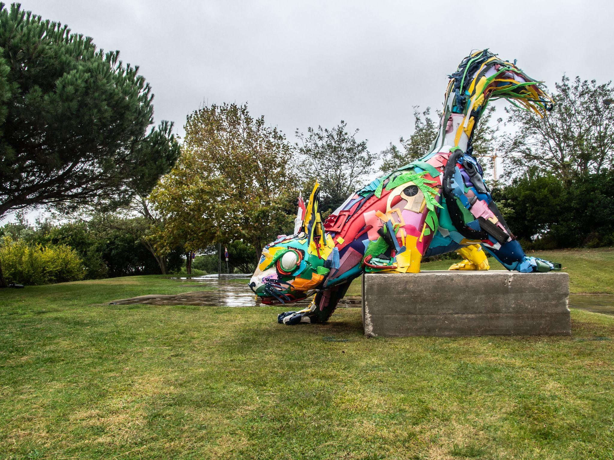
Previous Plastic Squirrel sculpture; courtesy of Bordalo II

Bordalo II (Lisbon, Portugal) is a street artist known for his unique and impactful artwork that convey powerful environmental messages. His artwork often centers around the concepts of excessive production and consumption, wherein he assembles discarded materials, such as old car parts, scrap metal, and plastic waste, to sculpt striking and thought-provoking animal portraits. By giving life to animals using the very materials responsible for their habitat destruction, Bordalo II highlights the urgent need for environmental conservation and waste reduction.

A colorful newly commissioned animal sculpture called Plastic Rooster will be on display in the heart of downtown New Bedford. The rooster was chosen for its common symbol of Portugal, where ​​55% of New Bedford’s population claim to have Portuguese forebears. Measuring approximately 12 feet long, 9 feet wide and 15 feet tall, the artwork will be created out of repurposed waste materials from the South Coast region and collected to be used for the site-specific artwork. Plastic Rooster will be created together with local landfill management departments and 11th grade Metal Fabrication students from the Greater New Bedford Regional Vocational Technical High School, empowering and building pride among the local and talented young people.

"Our partnership with DATMA has been nothing short of extraordinary,” shared Warley Williams III, Principal of the Greater New Bedford Regional Vocational Technical High School. “Since 2021, our students have been involved in fabricating outdoor displays but this year's project is truly groundbreaking. Working alongside an internationally acclaimed artist and a professional engineer on a semi-permanent sculpture right from the start is an unparalleled opportunity. This collaboration not only enriches our students' educational experience but also contributes to the vibrant cultural landscape of New Bedford.”

Plastic Rooster by Bordalo II will be on view outside, free and open to the public on the green space of the New Bedford YMCA at Union Street and North 2nd Street and is intended to be explored, interacted with and used as a backdrop for gathering and events. This artwork will be on display at this location through 2029.
The Art of Technology: Exploring Transformative Innovations of the SouthCoast photography exhibition
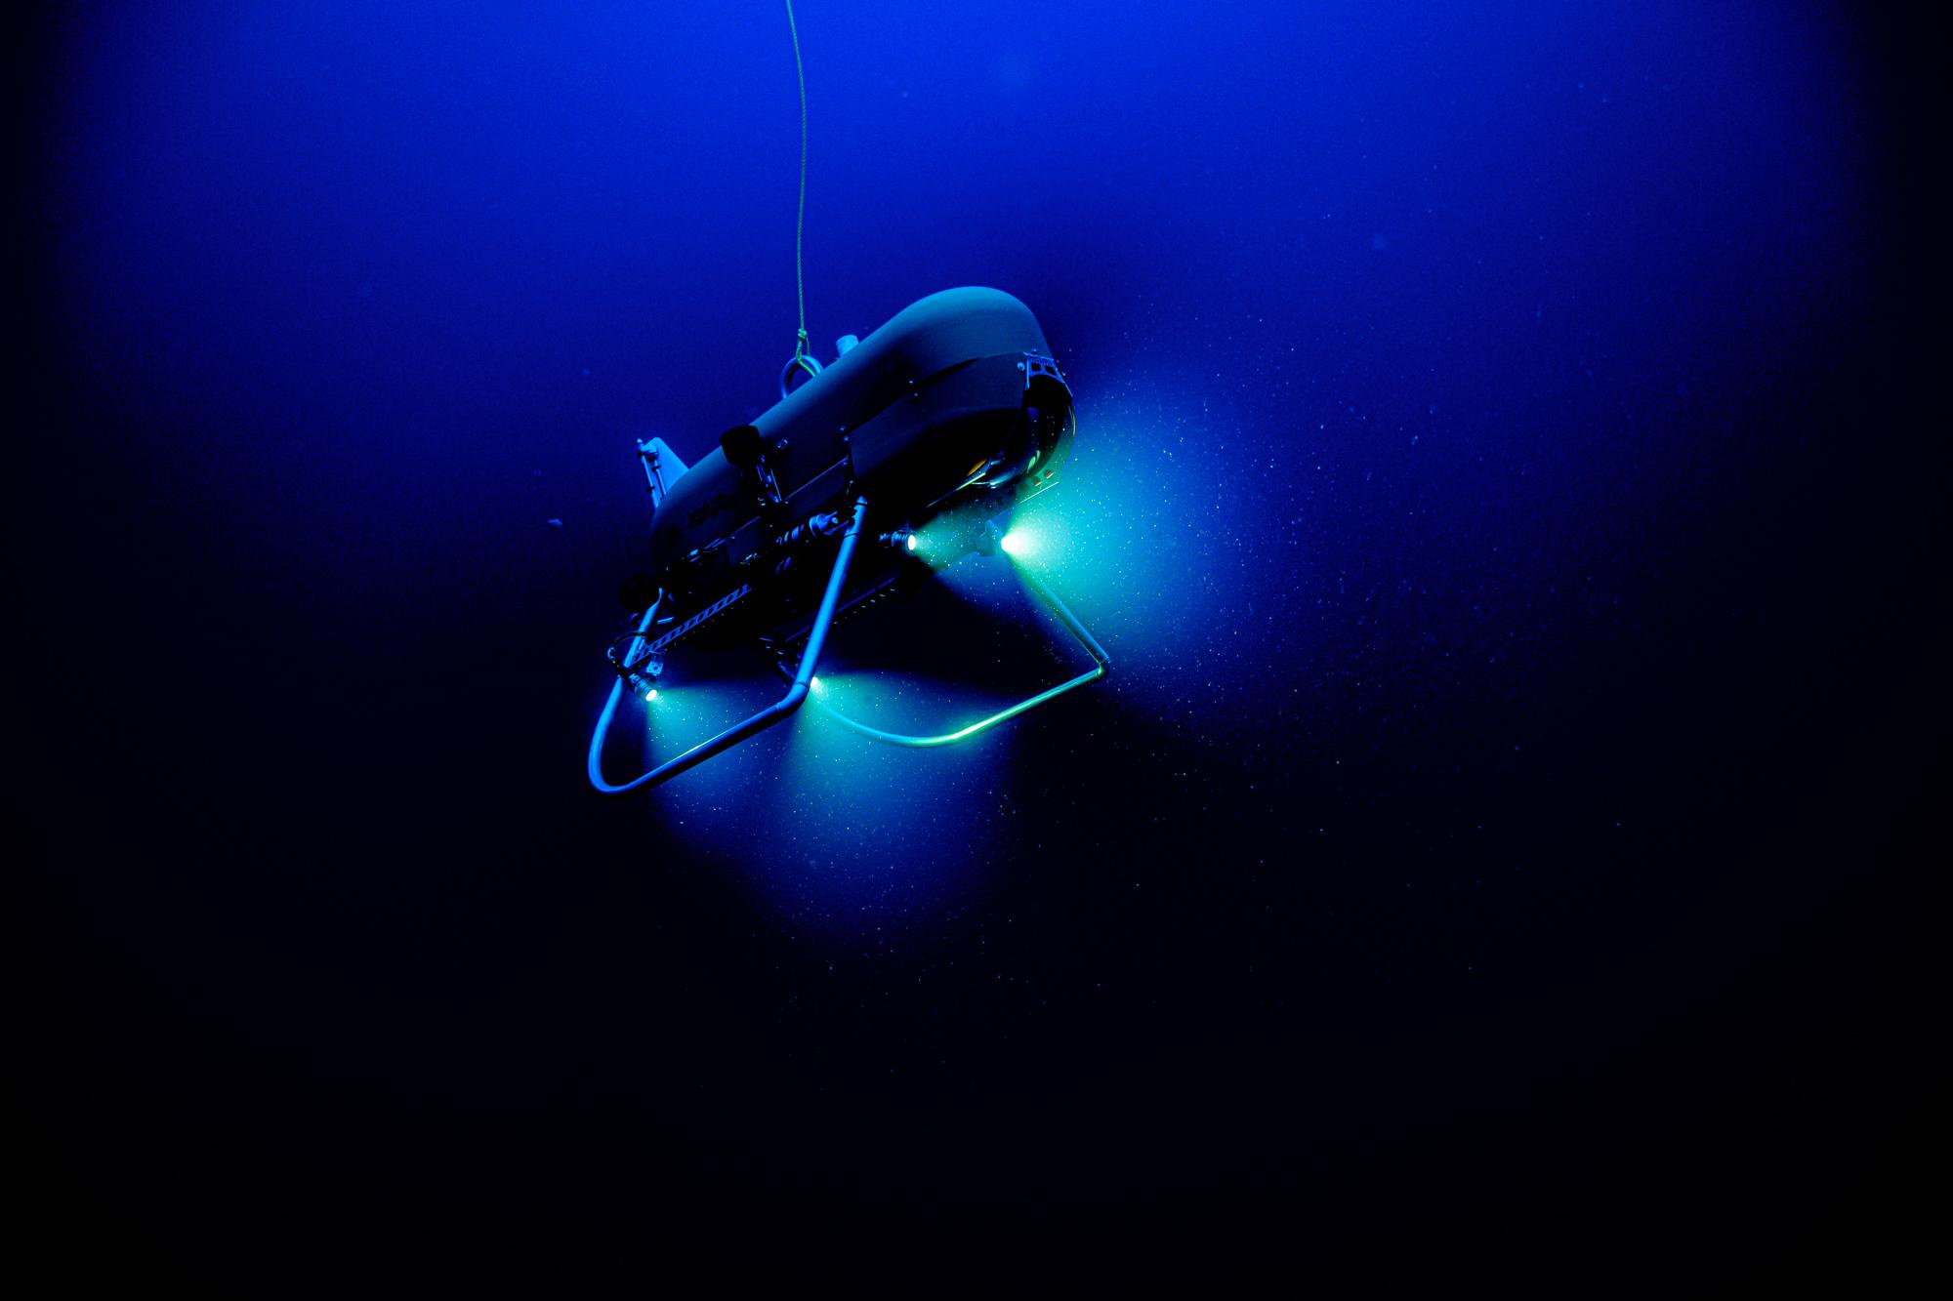
Orpheus, an Autonomous Underwater Vehicle (AUV) is capable of reaching the ocean’s greatest depths; courtesy of Woods Hole Oceanographic Institute
The Art of Technology: Exploring Transformative Innovations of the SouthCoast photography exhibition highlights technological innovations that are ushering in a transformative era for the SouthCoast of Massachusetts. Renewable energy initiatives such as offshore wind are reshaping the region's energy landscape, making it a hub for clean power generation. Advanced engineering and robotics technologies are revitalizing the local industry, leading to increased creativity, connection, and job growth. New Bedford's rich history as a fishing hub is now coupled with new technology applications in the industry, improving both efficiency and sustainability. Through large-scale graphics, design stories, and online resources, this photo exhibition will present the latest regional innovations that are positioning the SouthCoast as a leader in sustainable energy and creating a more dynamic and connected community.
The Art of Technology: Exploring Transformative Innovations of the SouthCoast photography exhibition will be on view at Tonnessen Park and entrance of Seastreak Ferry building in downtown New Bedford.
“Technology and the arts are intersecting in the SouthCoast more than ever, which is exactly what inspires my organization,” shared Lindsay Mis, Executive Director of DATMA. “We’re excited to help tell New Bedford’s story through our varied exhibitions with a well-known international artist while partnering with incredibly talented local youths and local organizations. It’s a collaborative effort from all sides and I am proud to see our community and industries working together in looking towards the future through a resourceful and creative lens.”

Public Programming and Workshops
Additional programming that are all free and open to the public during the TRANSFORM: Reduce, Revive, Reimagine season will include:

Saturday, May 11, 2024
10am - 12pm
DATMA Design Day with New Bedford Free Public Library presents "Trash to Treasures: Eco-Art Workshop"
At New Bedford Free Public Library, Youth Services Dept, 613 Pleasant Street, New Bedford.
Join us for a creative hands-on workshop where kids and families can explore the importance of recycling and waste reduction all while transforming discarded plastics into eco-friendly masterpieces. This free interactive event is fun for all ages and encourages appreciation for the environment and the power of creativity in sustainable practices. This event is presented as part of ArtWeek SouthCoast.

Thursday, June 13; July 11 and August 8, 2024
5:30pm - 6:30pm
Curators Tour: ‘Iterations’ at New Bedford Free Public Library
At the New Bedford Free Public Library, 613 Pleasant Street, New Bedford.
What is an original work of art? How can a painting transform when it’s in a different medium? In what ways does an image transform when recreated by a different artist? Led by Alexandra Copeland, Art Curator at New Bedford Free Public Library, this tour examines the transformative nature of art — from James Smillie’s engraving after Albert Bierstadt’s “The Rocky Mountains, Lander's Peak,” itself a later version of the library’s “Sunset Light, Wind River Range of the Rocky Mountains” to Louisa Ricketson’s painted copies of JMW Turner’s scenes of Venice, ‘Iterations’ includes a variety of artworks and pieces that inspired them.

Friday, June 14, 2024
10am - 12pm
Diálogo & Café
In downtown New Bedford (location TBD).
We invite all to join us for Diálogo & Café, a conversation about the creative process and public art with Lisbon street artist, Bordalo II, and Michael Benevides, Fabric Arts Festival Founder (and co-owner at Portugalia Marketplace). Joining will be Sarah Jane Mulvey, New Bedford's Poet Laureate who will continue the tradition of reading a new piece to start the season as well as a performance by members of the New Bedford Symphony Orchestra. A curator-led walking tour of DATMA's newest public art exhibition in historic downtown New Bedford will follow.

Thursday, July 11, 2024
5pm - 7pm
DATMA Design Day presents “WindWorks”
At Custom House Square in downtown New Bedford, 21 Barkers Lane, New Bedford.
This hands-on outdoor workshop is hosted by DATMA and Vineyard Wind where kids and adults alike can build DIY windmills, learn about wind energy, and discover how new wind energy initiatives in the SouthCoast can contribute to a cleaner future.
Thursday, August 8, 2024
5pm - 7pm
DATMA Design Day presents “Trash Transformed: Eco-Art Workshop”
At the YMCA lawn on 25 South Water Street, New Bedford.
Join us for a creative hands-on workshop outdoors on the YMCA lawn where kids and families can explore the importance of recycling and waste reduction, all while transforming discarded plastics into eco-friendly masterpieces. This free interactive event is for families and kids all ages, and presented during AHA! Night in New Bedford.

Thank you to all of DATMA’s partner and collaborating organizations: New Bedford YMCA, New Bedford Free Public Library, Casa da Saudade Library, Mass Audubon, New Bedford Symphony Orchestra, Vineyard Wind, New Bedford Research and Robotics, Woods Hole Oceanographic Institute, Our Sisters’ School, Greater New Bedford Regional Vocational Technical High School, New Bedford Food Tours, New Bedford Department of Public Infrastructure, Greater New Bedford Regional Refuse Management District, City of New Bedford, New Bedford Creative, and the Seaport Art Walk.

Full details and additional programs are available on www.DATMA.org/events
###
About the Massachusetts Design Art and Technology Institute (DATMA)
The Massachusetts Design Art and Technology Institute (DATMA) was founded to enhance the evolving dynamic cultural and economic life of Southcoast Massachusetts. DATMA is committed to bringing world-renowned art, design, and technology exhibitions, programs, and initiatives to the visitors and citizens of New Bedford and the region, identified as one of the Commonwealth’s most creative economies by the Massachusetts Cultural Council. As an exhibitor of public art, DATMA collaborates with the business and education sectors of the region to expand public awareness, bringing new cultural assets into the mix. www.datma.org

About Bordalo II
Artur Bordalo (Lisboa, 1987) is today known as Bordalo II, the artistic name he chose as a tribute to his grandfather, promoting a continuity and reinvention of his artistic legacy. His youth was spent in the company of his grandfather, the painter Real Bordalo and his incessant passion for watercolours, and his adventures around illegal graffiti in Lisbon’s underworld. He states that the eight years he spent at the Fine Arts Faculty of Lisbon allowed him to discover sculpture and the experimentation with various materials which distanced him from painting, the original art expression which led him there in the first place.

Bordalo II’s work often centers around the concepts of excessive production and consumption, wherein he assembles discarded materials, such as old car parts, scrap metal, and plastic waste, to sculpt thought-provoking animal portraits. By giving life to animals using the very materials responsible for habitat destruction, Bordalo II highlights the urgent need for environmental conservation and waste reduction. Bordola’s various artwork have been on view around the world including in Sacramento, Pittsburgh, Paris, Puerto Rico, Sao Paulo, Thailand, Azerbaijan, Mexico, Belgium, France, Germany, and around Portugal. www.bordaloii.com

