**DATMA ANNOUNCES 7th SEASON WITH**

**TWO OUTDOOR PUBLIC-ART EXHIBITS**

**IN NEW BEDFORD**

***Public Art Nonprofit Institute Unites Cutting-edge Technology and Community-Driven Art***

**NEW BEDFORD, MA** **JUNE 10, 2025** –[**Massachusetts Design Art and Technology Institute**](http://www.datma.org/) **(DATMA)**, the non-collecting contemporary art institute based in New Bedford, MA, will once again bring a variety of free public art and programs to New Bedford for summer 2025. DATMA will open its 7th season on June 13th with two exhibitions; *Being Seen*: *Celebrating Pride in the SouthCoast* and *Mood-Vironment*: *An Interactive A.I. Responsive Sculpture*.

# ***Being Seen: Celebrating Pride in the SouthCoast***

Being Seen is a collaborative tapestry created from upcycled textiles—more than 150 panels of sailcloth and other upcycled textiles cut into triangles and painted in a variety of colors to honor the LGBTQ+ community. The artwork was conceptualized by DATMA with the creative direction by Brooklyn based textile artist and activist, Liz Collins, who worked with students at UMASS Dartmouth’s College of Visual and Preforming Arts, ultimately creating a larger SouthCoast community initiative with more than 100 individuals and 17 organizations have contributed materials or created tapestry panels. The exhibit will debut on June 12 at the New Bedford Pride block party, and officially launch on June 13 with an opening at Gallery X from 6:00-8:00pm.

“To be totally transparent, I would never design a project for 100 people. That's insane,” DATMA Executive Director Lindsay Miś says. “But every time I spoke about this project, people wanted to get involved. Half of the project’s participants identify as queer and the other half are allies, meaning, people who have and/or had queer siblings and friends. Together, we are saying, this is your home.”

On view temporarily on the front façade of New Bedford City Hall from June 12 – June 22 will be the debut of the 3-story tall tapestry built of eighty 6.5’ x 6.5’ x 9.2’ panels. The presentation continues with over seventy additional panels displayed along William Street up to Gallery X, the location for the extended indoor exhibition of “Being Seen” will be on view at the gallery through July 12. The exhibition “Being Seen” presents a history of the Pride Movement, with a focus on the legacy of local figures such as David B. Boyce (1949-2014). Boyce is portrayed by sculptor George Segal in The Gay Liberation Monument, part of the Stonewall National Monument in New York City. With an introduction to the exhibition written by Michael J. Bobbitt, Executive Director of Mass Cultural Council, (MCC), honored are other local figures prominent in advocating for Massachusetts’s Marriage Equality Act that paved the way for the rest of the nation. In addition to DATMA’s exhibition, this exhibit will present a group show of artwork by local LGBTQ+ artists organized by Kate Frazer Rego and Gallery X. Being Seen is DATMA’s first travelling exhibition and will travel from New Bedford to Dartmouth, Marion, and then Fall River through 2026.

***Mood-Vironment: An Interactive A.I. Responsive Sculpture***

Mona Ghandi’s *Mood-vironment* is an interactive walk-through sculpture that provides a dynamic, immersive atmosphere through its interactive sound response and color-changing effect—a function of sensor-and-lighting technology. Embedded sensors respond to the viewers’ physical presence and voice that trigger constant changes to light and sound. By positioning viewer participation and emotions at the very center of its socially responsive space, the sculpture aims to emphasize emotions as a fundamental part of the collective identity, a type of experiential public art.

“This outdoor installation is a real manifestation of DATMA’s public-art, technology, and design mantra and mission,” says Nicholas Sullivan, Chair of DATMA. “It is both experimental as an outdoor piece – and experiential, in a very interactive way, thanks to AI and machine-learning technology. It’s always exciting and sometimes nerve-wracking to see these one-of-a-kind pieces come together.”

Ghandi has been designing and building similar structures for indoor use for more than a decade; this is her first outdoor sculpture. It was designed in Seattle, fabricated in Virginia, and assembled by a 10 person team over a two-week period. The sculpture, made from wood and fabric, stands 20’W x 20’L x 11’H. The outdoor sculpture installation is scheduled to be in place June 13–October 13, 2025 at 82 Front St, New Bedford, MA 02740.

Full details and additional programs are available on [www.DATMA.org/events](http://www.datma.org/events)

###

**About Mona Ghandi (WA)**

Mona Ghandi is an architect and educator who graduated from the University of California, Berkeley. She currently teaches at Washington State University in Seattle. As an associate professor of architecture and founder of the Morphogeneis Lab, she specializes in Emotive and Performative Intelligent Architecture, intertwining architecture with fields such as computer science, neuroscience, psychology, and materials. Her work uses AI, machine learning, affective computing, and robotics to creative, adaptive, inclusive, sustainable architectural solutions. Her interdisciplinary research aims to revolutionize how we perceive and interact with our surroundings, addressing crucial topics like well-being, social justice, and environmental sustainability in design. Her work has been featured in various international exhibitions, including the Venice Biennale, and recognized with several prestigious awards such as the World Architecture Award and the Architizer A+Award in Architecture and Tecnhology. DATMA selected Ghandi through an RFP (request for proposal) process in 2023 (?).

*Mood-Vironment*, in part, was supported by a National Endowment for the Arts (NEA) Challenge America Award— the first such NEA award to a New Bedford organization—as well as a grant from New Bedford’s Office of Tourism, Explore New Bedford.

**About Liz Collins (NYC)**

Visiting Creative Director Liz Collins is a multi-media artist who works fluidly between art and design, with emphasis and expertise in textile media. Collins received a BFA and MFA from RISD in 1991 and 1999, then launched her own knitwear-focused fashion label with a runway presentation in New York during fashion week. After teaching at RISD (2003-2013), she has since taught at SAIC, MICA, Pratt, Parsons, and Moore College. In addition to exhibiting internationally, Collins’ honors include an Anonymous Was a Woman Fellowship, a USA Fellowship, a MacColl Johnson Fellowship, Foundation for Contemporary Arts & Artist Relief grants, Drawing Center Open Sessions and residencies at Siena Art Institute, MacDowell, Yaddo, Haystack, and Museum of Arts and Design. One of her most notable projects is Knitting Nation (2005-2016), which has been staged and presented in 15 locations around the world. Knitting Nation was an inspiration and model for *Being Seen*.

**About the Massachusetts Design Art and Technology Institute (DATMA)**

The Massachusetts Design Art and Technology Institute **(**DATMA) was founded to enhance the evolving dynamic cultural and economic life of Southcoast Massachusetts. DATMA is committed to bringing world-renowned art, design, and technology exhibitions, programs, and initiatives to the visitors and citizens of New Bedford and the region, identified as one of the Commonwealth’s most creative economies by the Massachusetts Cultural Council. As an exhibitor of public art, DATMA collaborates with the governmental, business, and education sectors of the region to expand public awareness, bringing new cultural assets into the mix. [www.datma.org](http://www.datma.org)

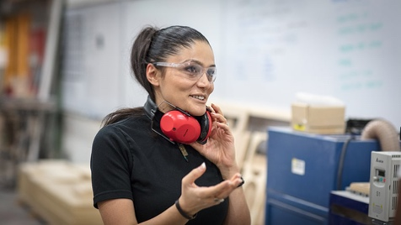**Attached are the following images:**

Headshot, Mona Ghandi

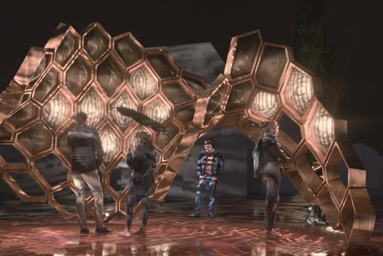Mona Ghandi, “Mood-vironment” (rendering credit: Morphogenesis Lab, Mohammad Tabatabaei Manes, Mona Ghandi)

Headshot, Liz Collins, image courtesy of Liz Collins

Detail of Being Seen tapestry in-process at DATMA, image courtesy of DATMA

