Media contact:
Lindsay Miś, DATMA Exec Director
director@datma.org
Ph: 774-264-3696
For immediate release:

DATMA Presents Pop-up Exhibition of Iranian Contemporary Artworks
Through DATMA’s “art in public spaces initiative,” vacant storefronts are being filled.
NEW BEDFORD, MA June 29, 2026 Still We Bloom: Stories of Memory, Migration, and Renewal is a pop-up exhibition featuring eight Iranian artists exploring belonging across places, cultures, and time. The multi-media exhibition includes 2D and 3D artworks by Arghevan Booyeh (mixed media sculptor), Anis Beigzadadeh (Ceramics), Sarah Valinezhad (painter), Maryam Seraji (Illustration), Zara Shahi (Fiber), Elham Hajesmaili (Painter), Ali Masoumzadeh (Painter), and Azin Majooni (Printmaking). Their works move between memory and presence, grief and hope, tracing identities shaped by movement, change, and endurance.
“Like seeds carried across great distances, we take root in unfamiliar ground. We adapt, persist, and continue to grow,” says Arghevan Booyeh, “that is why we titled the show, Still We Bloom.” Booyeh is one of the featured artists in the exhibition. She is completing her Masters thesis in the UMass Dartmouth CVPA graduate program with a focus in textiles and fiber.
“Not only is this exhibition content profound and relevant, but each of the artworks has a stand-alone presence required to visually fill the floor-to-ceiling windows offering viewers an experience from out on the sidewalk or inside the gallery,” says Lindsay Miś, DATMA’s Executive Director.
The exhibition is a temporary pop-up exhibition installed at 127 Union Street in New Bedford. In partnership with Lanagan & Co, Inc., New Bedford Creative, and Massachusetts Design Art & Technology Institute, DATMA, the exhibition fills a vacant storefront activating the historic downtown contributing to the city’s arts and culture happenings during the month of July. Opening to the public on the July 9th AHA! Night from 5-9pm with artist talks and music provided by AnjKep, visitors can continue to access the exhibition through July 30th on Wednesdays and Fridays from 4-7pm or by appointment.
For more information, please visit https://datma.org/explore/still-we-bloom/
###
About the Massachusetts Design Art and Technology Institute (DATMA)
The Massachusetts Design Art and Technology Institute (DATMA) was founded to enhance the evolving dynamic cultural and economic life of Southcoast Massachusetts. DATMA is committed to bringing world-renowned art, design, and technology exhibitions, programs, and initiatives to the visitors and citizens of New Bedford and the region, identified as one of the Commonwealth’s most creative economies by the Massachusetts Cultural Council. As an exhibitor of public art, DATMA collaborates with the business and education sectors of the region to expand public awareness, bringing new cultural assets into the mix. www.datma.org
IMAGE FILES ATTACHED SEPARATELY- TITLE DETAILS PROVIDED BELOW
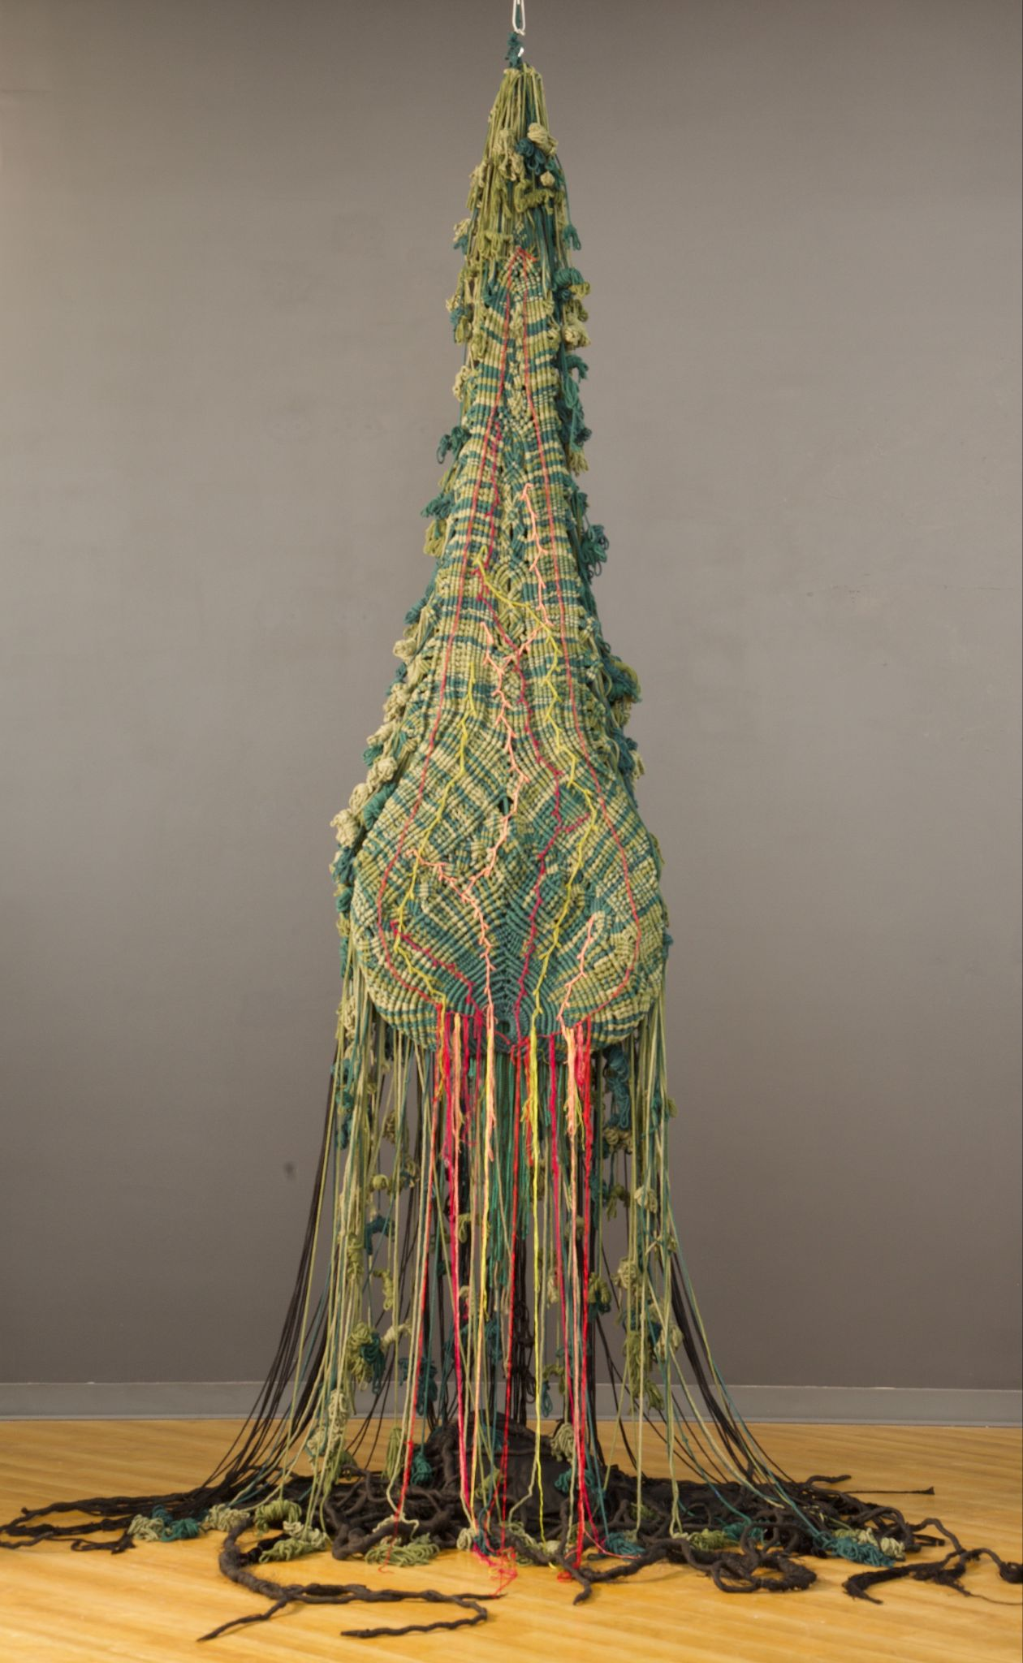
“The Hero Rises” 2024-2025 by Arghavan Booyeh.
Materials: Cotton, Macrame Cord, bronze.
Dimensions: 127 x 30 x 25 inches
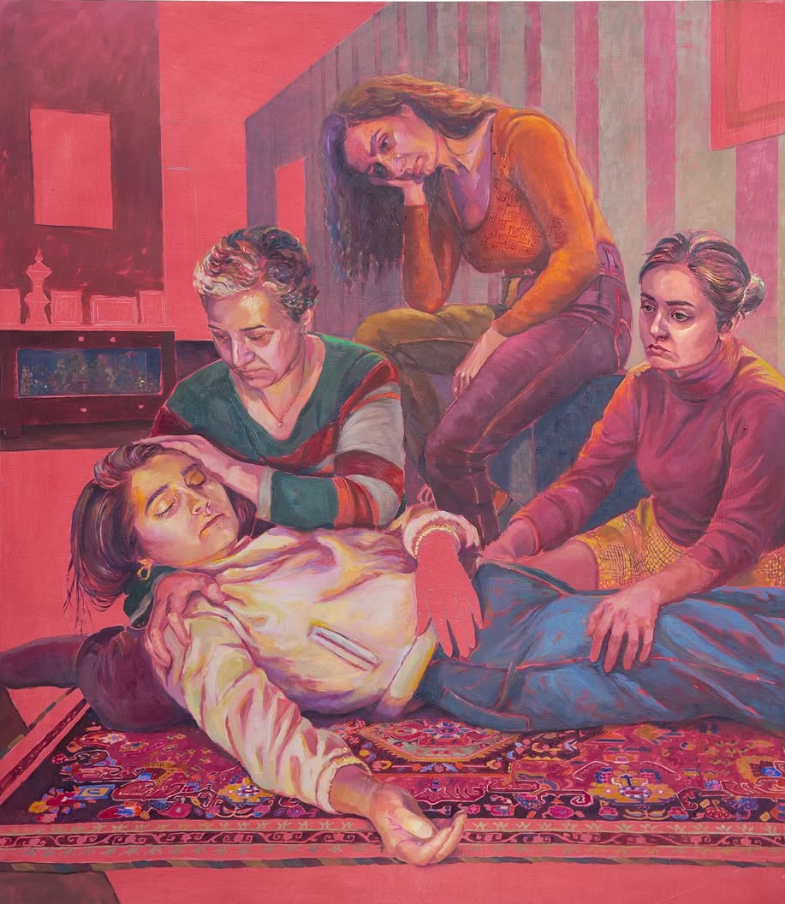
“If I Put You Down, You Would Be Gone” 2026 by Sarah Valinezhad
Materials: Oil on canvas
Dimensions: 35 x 40 inches

